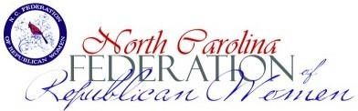

RISE AWARDS

WOMEN ON THE RISE 2023

Recruitment Involvement Service
Education
The RISE Award is given annually to clubs that reached the four RISE goals in the previous year.

- Recruitment: Increased Club Membership from the year end of 2023 by the following (Club RISE goal is listed on Club membership report):
  - 10 - 15 members, increase by 2
  - 16 - 19 members, increase by 2
  - 20 - 44 members, increase by 3
  - 45 – 60 members, increase by 3
  - 61 – 70 members, increase by 4
  - 71 plus members, increase by 4

- Involvement: A Club Representative attended any two of the three NCFRW 2023 Board Meetings – February in Raleigh, May in Charlotte or November in Winston-Salem, NC.

- Service: List the total 2023 community volunteer hours your club submitted, like Caring for America, Armed Services, etc. (not Campaign/Political Hours).
- Education: Club Project – Letters to Editor, Get Out the Vote effort, Poll Observing, Adopt a Candidate, Candidate forum - whatever works best in your area for your club.
Clubs attaining these goals will be recognized at the Winter Board Meeting!

